“Robotics, Autonomous Vehicles, and Smart Logistics”
Syllabus SCA.05/3

Prof K. Kyamakya, Prof J.C. Chedjou, AAU/Austria

October, 20th, 2018

Version 1

1. Title of the Course

Robotics, Autonomous Vehicles, and Smart Logistics
(Prof K. Kyamakya, Prof J.C. Chedjou, AAU/Austria)
2. ECTS Credits

6 credits (Lecture - 45 hours, Practice - 30 hours), 3rd semester

3. Course Objectives

The course consists of 3 Modules:

- MODULE A: Introduction to Robotics
- MODULE B: Autonomous Vehicles overview
- MODULE C: Smart Logistics overview

4. The Contents of the Lecture

MODULE A: INTRODUCTION TO ROBOTICS

- Introduction
  - What is robotics
  - Robot mechanical structures (robot manipulators, mobile robots)
  - Industrial robotics
  - Advanced robotics (field robots, service robots)
  - Robot modelling, planning and control
- Selected challenges
  - Intelligence and embodiment
  - A roboticist’s problem
  - Ratslife
  - Challenges of mobile autonomous robots
  - Challenges of autonomous manipulation
- Locomotion and manipulation
  - Locomotion and manipulation examples
  - Static and dynamic stability
  - Degrees-of-freedom
- Forward and inverse kinematics
  - Coordinate systems and frames of reference
  - Forward kinematics of selected mechanisms
  - Forward kinematics using the Denavit-Hartenberg scheme
  - Inverse kinematics of selected mechanisms
  - Inverse kinematics using Feedback-Control
- Path planning
- Trajectory planning
- Actuators and internal sensors for robots
- External environment perception sensors
- Control architectures
- Artificial intelligence reasoning and learning for robots
  - Artificial intelligence reasoning
    - Why should a robot use AI-Type reasoning?
    - Knowledge representation and processing
    - Reasoning and decision making
    - Plan-based robot control
  - Robot learning
    - What is robot learning
    - Model learning
    - Reinforcement learning

MODULE B: Autonomous Vehicles overview

- Benefits of autonomous driving
(reduce accidents, reduce travel time, reduce travel costs, etc.)
- General architecture and autonomous driving technology overview
- Selected technologies enabling autonomous vehicles
  - Sensors (cameras, lidar, ultrasonic sensors)
  - Electronic control systems (throttle system, brake-by-wire, steer-by-wire, shift-by-wire)
  - Computer processing
  - Software (software architecture, sensor fusion, simultaneous localization and mapping, simulation, machine learning)
  - HD mapping (localization)
  - Vehicle-to-X Communications
  - 5G communications
  - Electric vs. Hybrid Vehicles

- Categories and levels of automation
  - Categories of autonomous driving (semi-, sufficiently-, fully-)
  - SAE levels of autonomous driving
  - Basic driver assistance functions
  - Semi-autonomous driving functions
  - Sufficiently-autonomous driving
  - Special situations
  - How an autonomous system sees the world
  - Interior of autonomous vehicles
- Autonomous driving algorithms
  - Sensing
  - Perception
  - Object recognition and tracking
  - Action
- Autonomous driving client system
  - Robot operating system (ROS)
  - Hardware platforms
- Autonomous driving cloud platform
  - Simulation
  - HD map production
  - Deep learning model training
- Prediction and routing
  - Planning and control overview
  - Traffic prediction
  - Lane level routing
- Trucks, Delivery Vehicles, and Buses
  - Ridesharing systems
  - Autonomous trucking
  - Autonomous package delivery
  - Autonomous food delivery
  - Autonomous shuttle services
  - Autonomous bus transportation
  - Military autonomous vehicles

MODULE C: SMART LOGISTICS OVERVIEW
- A brief introduction to logistics and supply chains
  - Definitions of the core concepts: logistics, supply chain, E-logistics
  - Supply chain, a brief survey
  - Logistics, a brief survey
  - Inventory management in supply chains, a brief survey
  - E-logistics – historic development
- Supporting ICT infrastructure for future logistics
  - ICT and logistics
  - Intelligent transportation systems
  - Smart grids
  - The convergence infrastructure for ITS and the smart grid
  - Applications of a convergence infrastructure for ITS and the smart grid
- ICT for airfreight management
  - Introduction
  - Airfreight – the challenges
  - The airfreight supply chain
  - Customer interfaces
  - Issues
- ICT for rail freight management
  - Introduction
  - Basic principles of ICT for rail freight operations
  - What do rail freight customers want?
  - Tracking and tracing information for customers
  - Other ICT applications that help rail freight to play to its strengths
  - The role of ICT for rail freight in European railways
- ICT for efficient road freight transport
  - Introduction
  - Skylark cargo services
  - Cloud computing
  - Telematic data
  - Data sources
  - IT system development
  - Big data
- Port-centric ICT system
  - Introduction
  - The importance of ICT to port systems
  - The port-centric ICT
  - Information matrix of port-centric ICT
  - ICT investment
  - Port community systems
  - Policy implications

6. Training method

Theoretical part of the course:
- Slides (to be placed in Moodle)
- Selected videos fitting the respective chapters (sources: Youtube, online open courses, etc.)
- Small weekly assignments. Deliverables-1: solutions to be uploaded in Moodle

Practical part of the course:
- Some selected exercises on both Kinematics and Inverse Kinematics
  - Deliverables-2: 2 homeworks; solutions to be uploaded in Moodle
- Some simple simulations of autonomously driving cars
  - Deliverables-3: Demos to be presented in front of all the class
- 3 students mini-seminars in groups of 2 students; 1 topic for each module
  - Deliverables-4 for each mini-seminar: 20 minutes presentations for each group
- A complex research project / study on a selected theme (teacher suggests some topics) of relevance to the course
  - The research project may involve programming of some robotics kits or the use of some relevant open source simulation software.
  - Deliverables-5: (1) a 20-30 minutes presentation; (2) A 6 pages paper/report summarizing the project/research outcome. Format: IEEE paper style. Paper editor: Latex.
- If possible, one industrial visit in a company working in one of the three relevant fields (i.e. robotics, automated vehicles, logistics).

7. Evaluation method

Students are evaluated by progressive control/assessment through the 5 Deliverables listed above and a final written exam control.

The final grade has 2 major components:
- Deliverables-1; the weekly assignments accompanying the theoretical course: 10%
- 4 Deliverables: -2, -3, -4 and -5: 50%
- Final written exam: 40%

8. Software

Kinematics simulation software:
https://www.psmotion.com/examples/kinematic-software

ROS (robotics operating software): http://www.ros.org/

Carla (Open-source simulator for autonomous driving research): http://carla.org/

9. Bibliography / Recommended textbooks

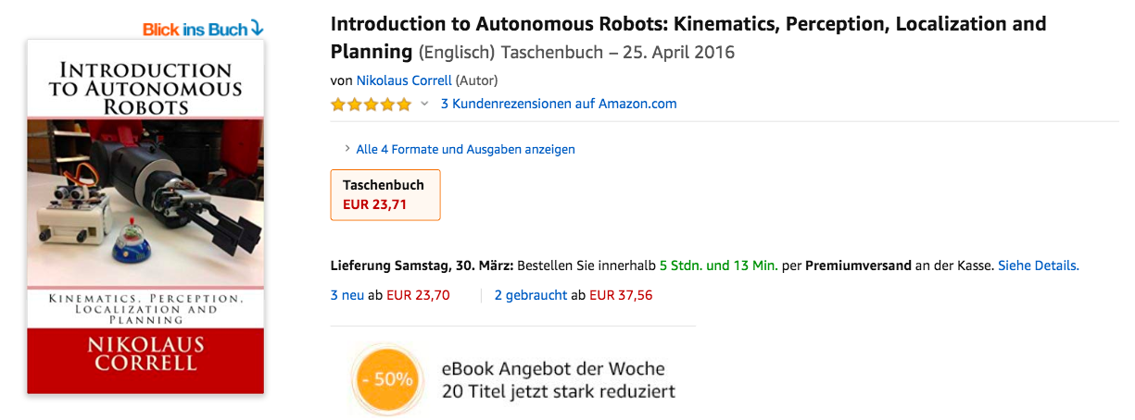

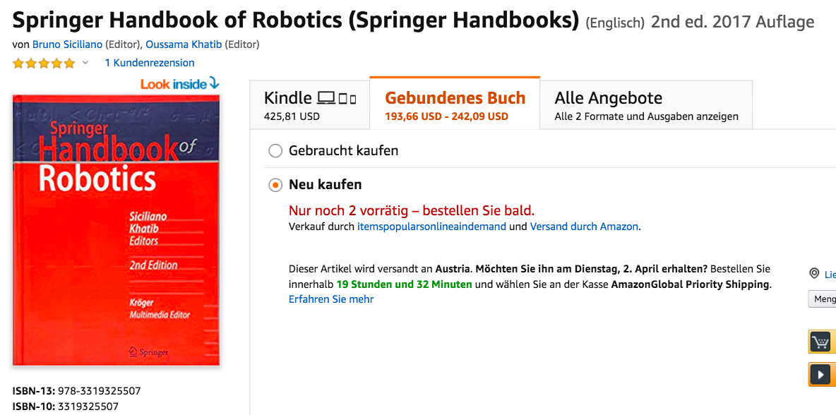

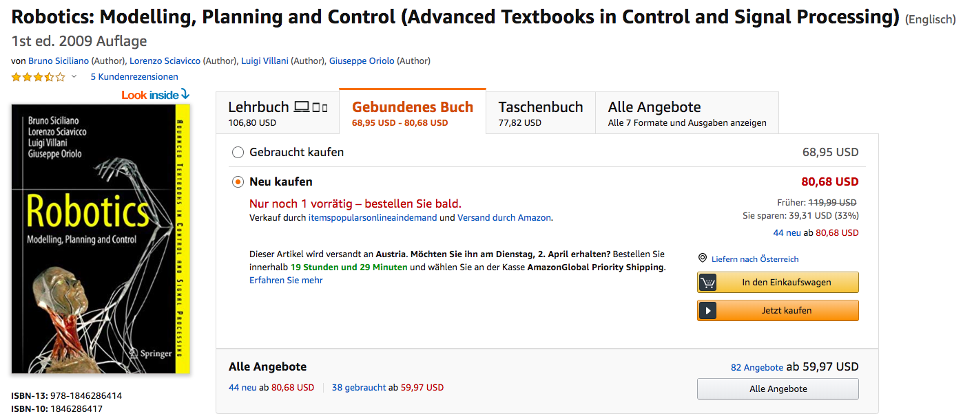





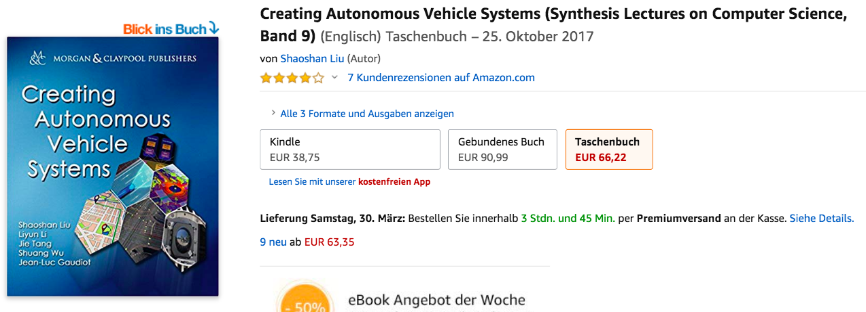

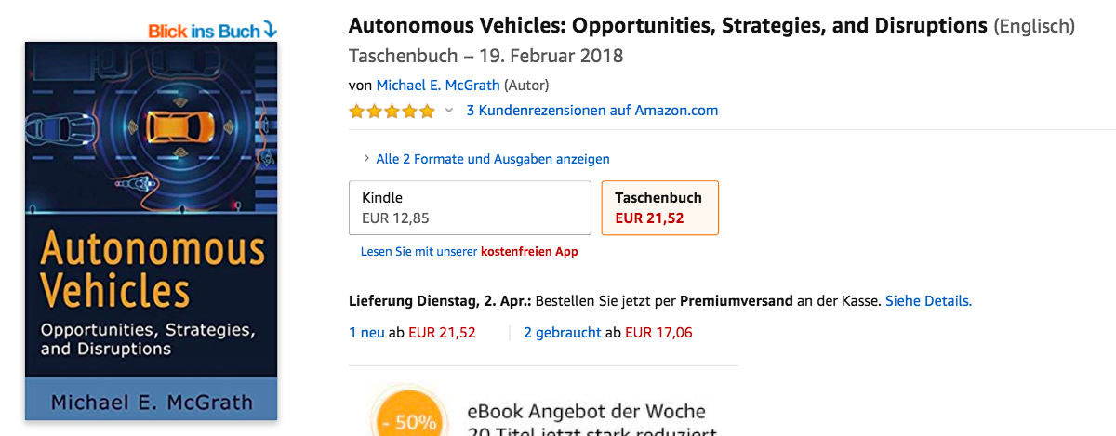

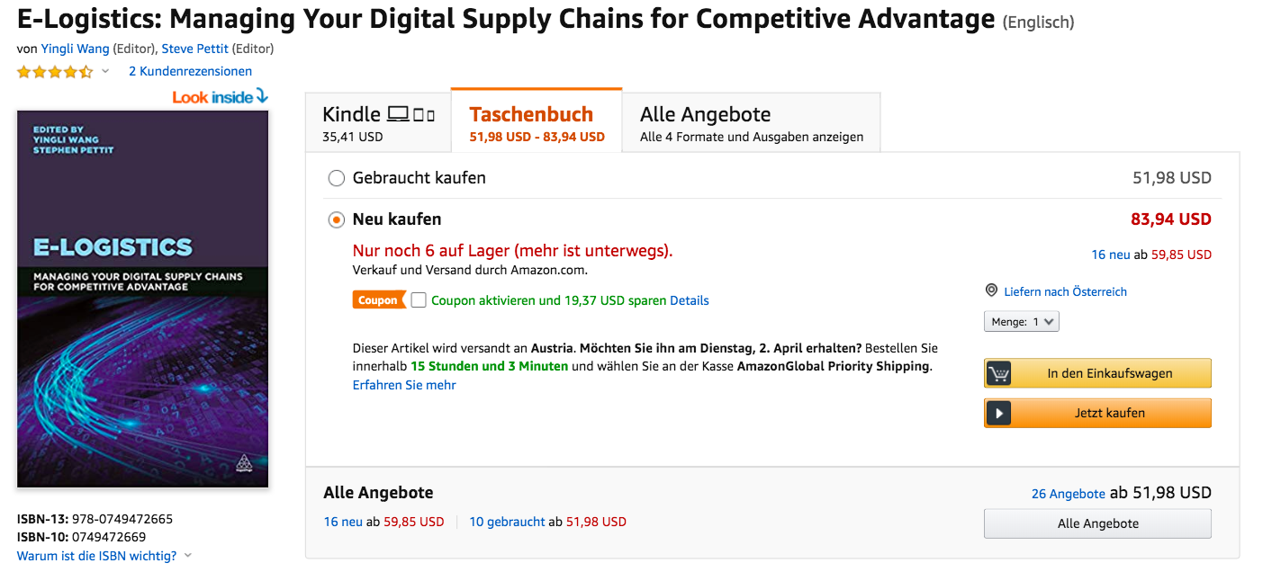

Source: Chapter 1 of the following book: https://www.amazon.com/dp/1846286417/ref=rdr_ext_tmb
Source: Chapter 1 of the following book: https://www.amazon.de/dp/0692700870/ref=rdr_ext_tmb
Source: Chapter 2 of the following book: https://www.amazon.de/dp/0692700870/ref=rdr_ext_tmb
Source: Chapter 3 of the following book: https://www.amazon.de/dp/0692700870/ref=rdr_ext_tmb
Source: Chapter 4 of the following book: https://www.amazon.de/dp/0692700870/ref=rdr_ext_tmb
Source: see Chapter 4 of the following book: https://www.amazon.de/dp/1846286417/ref=rdr_ext_tmb
Source: see Chapter 5 of the following book: https://www.amazon.de/dp/1846286417/ref=rdr_ext_tmb
Source: see Chapter 6 of the following book: https://www.amazon.de/dp/1846286417/ref=rdr_ext_tmb
Source: see Chapters 14 and 15 of the following book: https://www.amazon.de/dp/3319325507/ref=rdr_ext_tmb
Source: see Chapter 3 of book: https://www.amazon.de/dp/1980313857/ref=rdr_ext_tmb
Source: see Chapter 1 of book: https://www.amazon.de/dp/1681730073/ref=rdr_ext_tmb
Source: see Chapter 6 of book: https://www.amazon.de/dp/1980313857/ref=rdr_ext_tmb
Source: see Chapter 2 of book: https://www.amazon.de/dp/1980313857/ref=rdr_ext_tmb
Source: see Chapter 1 of book: https://www.amazon.de/dp/1681730073/ref=rdr_ext_tmb
Source: see Chapters 1 and 8 of book: https://www.amazon.de/dp/1681730073/ref=rdr_ext_tmb
Source: see Chapters 1 and 9 of book: https://www.amazon.de/dp/1681730073/ref=rdr_ext_tmb
Source: see Chapter 5 of book: https://www.amazon.de/dp/1681730073/ref=rdr_ext_tmb
Source: see Chapter 5 of book: https://www.amazon.de/dp/1980313857/ref=rdr_ext_tmb
Source: see Chapter 2 of book: https://www.amazon.com/dp/0749472669/ref=rdr_ext_tmb
Source: see Chapter 3 of book: https://www.amazon.com/dp/0749472669/ref=rdr_ext_tmb
Source: see Chapter 4 of book: https://www.amazon.com/dp/0749472669/ref=rdr_ext_tmb
Source: see Chapter 5 of book: https://www.amazon.com/dp/0749472669/ref=rdr_ext_tmb
Source: see Chapter 7 of book: https://www.amazon.com/dp/0749472669/ref=rdr_ext_tmb

