“Digitalization and Automation in Railway Transport”

Syllabus SCR.06/3

Prof K. Kyamakya, Prof J.C. Chedjou, AAU/Austria

March, 21th, 2019

Version 1

Digitalization and Automation in Railway Transport
(Prof K. Kyamakya, Prof J.C. Chedjou, AAU/Austria)

2. ECTS Credits

5 credits (Lecture - 45 hours, Practice - 30 hours), 3rd semester

3. Course Objectives

Digitalization encompasses the processes by which digital technologies and information are used by business sectors and public administrations to modify their organizational models, improve their performance and create new value.

Four levers of digital transformation for an industry:
- digital data, which, once collected and analyzed, provide for better predictions and decisions;
- automation systems, which increase speed, and reduce error rates and operating costs;
- connectivity, which synchronizes supply chains and shortens innovation cycles; and
- digital customer access, which enables companies to offer customers transparency and new services.

Rail digitalization offers a wide range of short- and medium-term potential services and applications. New solutions such as passenger and freight information services, video surveillance, smart infrastructure, monitoring of assets, signaling systems, and automated train control systems have the common objective of improving the efficiency of operations and serving the customer more effectively.

5. The Contents of the Course

- What is Digitization? – The four levels of digital transformation
  - Digital data
  - Connectivity
  - Automation
  - Digital customer access
- Roadmap for digital railways
  - Offering connected railways by providing reliable connectivity for safe, efficient and attractive railways
  - Enhancing customer experience by offering better and added value for customers
  - Increasing capacity by enhancing reliability, efficiency and performance of railways
  - Boosting rail competitiveness by making the most of transport data.

- Evolution of the Internet
  - At connectivity and infrastructure level (IoC, IoD, IoS, IoT, IIoT, IoE, IoTSP, IoRT, IoET)
  - At the content and service level (Web 1.0, Web 2.0, Web 3.0, Web 4.0, Web 5.0)
- Key enabling technologies
  - Internet of Things (IoT)
  - Cloud Computing
- Software as a service (SaaS), Platform as a service (PaaS); Infrastructure as a service (IaaS), Anything as a service (XaaS), Big data as a service (BaaS)
  - Big data analytics
  - Industry 4.0 & Industrial Internet of Things (IIoT)
  - Railway 4.0
  - 5G for Railways – Fifth generation of mobile telecommunication technology for Railways
- Digitization in Rail Transport
  - Connected Commuter: digital services for passengers
  - MAAS (Mobility as a Service): Towards intermodal urban mobility
  - PMAAS (Predictive Maintenance as a Service): digital services for rolling stock predictive maintenance
- GOA 4.0 (Grade of Automation 4): Automation and integration of train control systems
    - Some mathematical and systems fundamentals of rail Automation
    - Grade of automation and train control systems (from GOA1 to GOA4)
    - Examples of fully automated metros worldwide
    - The European Shif2Rail vision
    - Digital Interlocking
- The Internet of Trains – Creating value for multiple stakeholders
  - IoT Solutions for particular stakeholders
      - IoT for manufacturers (real-time access to information about particular train components helping prevent defects)
      - IoT for the train operator (a better understanding of the passenger’s needs, the possibility to offer embedded services in cooperation with partners, real-time maintenance data updating allowing for predictive maintenance)
      - IoT for Infrastructure manager (real-time access to data about the location and movement of trains helping reduce safety hazards and helping plan and carry out infrastructure maintenance)
      - IT Platform operator (the possibility to offer embedded services in cooperation with partners, added value of services created by digital business models)
  - A broad range of services for customers (more informative websites, mobile applications providing reservation, ticketing, timetables and real-time information, onward journey planning, and an on-board combination of information and leisure services (often referred to as infotainment))
  - Fixed assets and rolling-stock monitoring and management
  - Automated train operations (ATO)
- The European Rail Traffic Management System (ERTMS): the backbone of digital trains (in Europe)
- Analysis of an illustrative concept in a developed Country, Germany: DB 4.0 – concept of digital transformation (Digital transformation strategy of the German Deutsche Bahn)

- Selected topics for Students Research Seminars or Research Projects (in groups of 2 students per group):
- Predictive maintenance for railways and trains – an overview of the related literature. Feasibility analysis for the Uzbekistan railways operator.
- Concept development and feasibility analysis of an “IoT for the railway infrastructure manager” System in Uzbekistan”
- Detailed analysis of various “5G Projects for Railways”. Feasibility analysis for the Uzbekistan context.
- Detailed analysis of Digital Services for Railways. Feasibility analysis for the Uzbekistan context.
- Concept development and feasibility analysis of a “Logistics 4.0” system for the railway sector of Uzbekistan.

6. Training method

Theoretical part of the course:
- Slides (to be placed in Moodle)
- Selected videos fitting the respective chapters (sources: Youtube, online open courses, etc.)
- Small weekly assignments. Deliverables-1: solutions to be uploaded in Moodle

Practical part of the course:
- Some IoT simulation experiments: use some open source IoT simulation software
  - Deliverables-2: demos of the prepared simulations
- A complex research project / study (in groups of 2 students per group) on a selected theme (teacher suggests some topics) of relevance to the course – see examples of themes in point (10) above.
  - Deliverables-3: (1) a 30 minutes presentation; (2) A 6 pages paper/report summarizing the project/research outcome. Format: IEEE paper style. Paper editor: Latex.
- If possible, one industrial visit in a company working in a relevant field.

7. Evaluation method

Students are evaluated by progressive control/assessment through the 5 Deliverables listed above and a final written exam control.

The final grade has 2 major components:
- Deliverables-1; the weekly assignments accompanying the theoretical course: 10%
- 2 Deliverables: -2 and -3: 50%
- Final written exam: 40%

8. Software

https://thingsboard.io/

https://www.bevywise.com/iot-simulator/download.html

9. Bibliography / Recommended textbooks

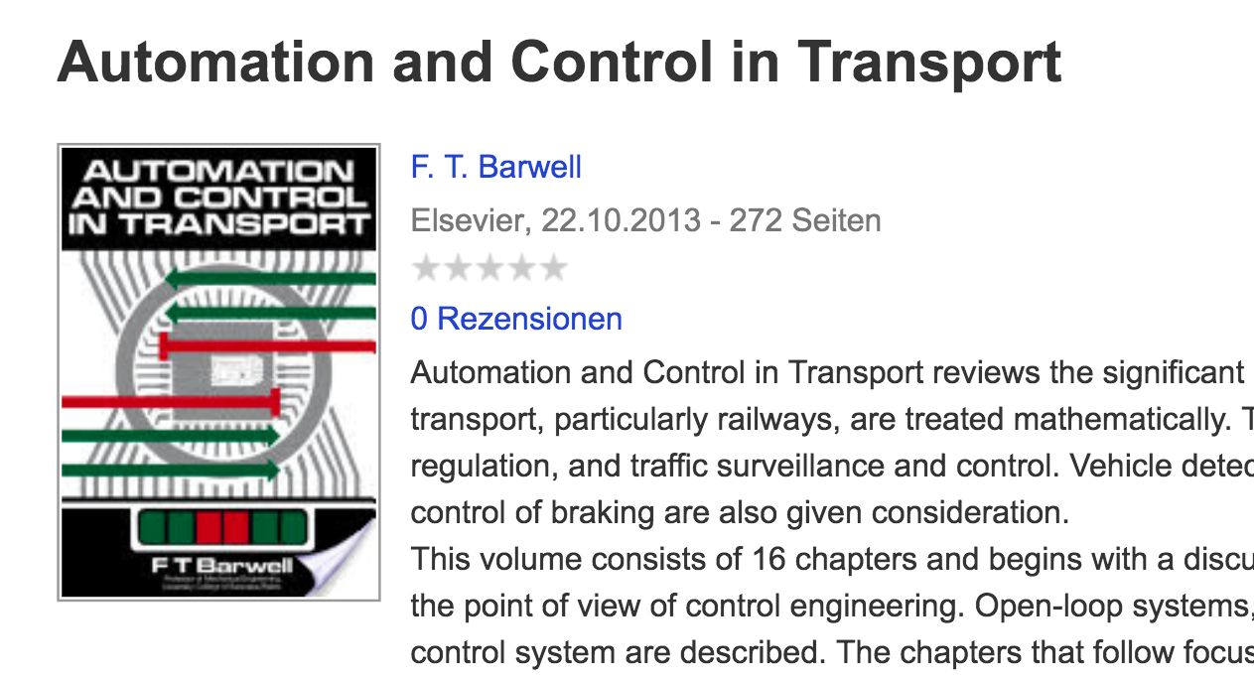

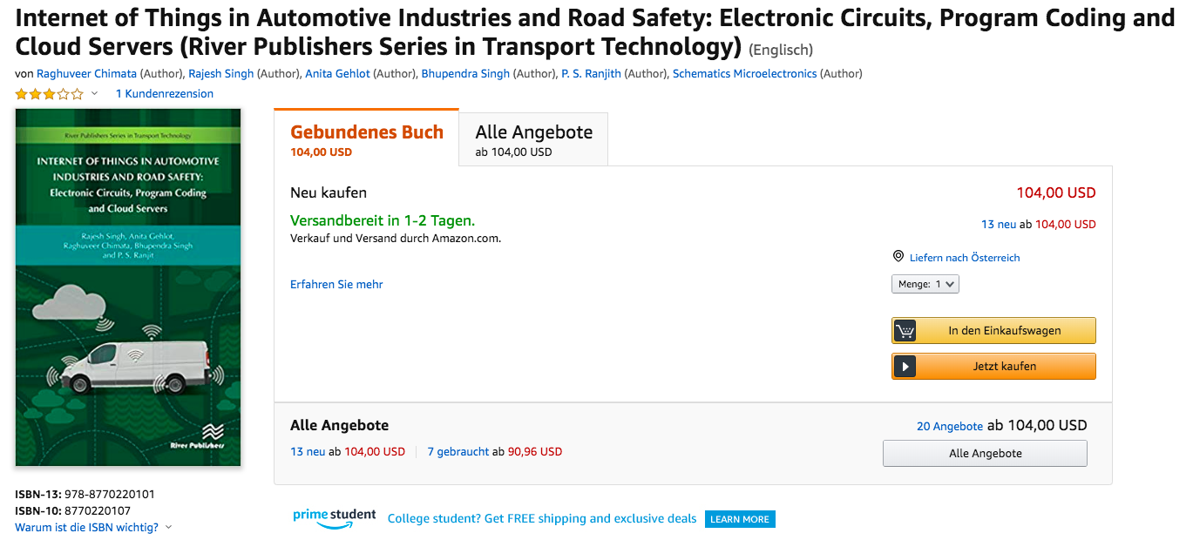

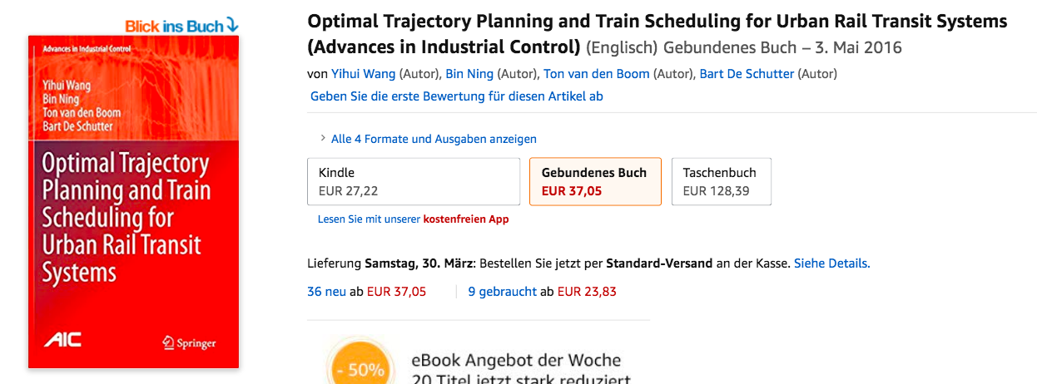

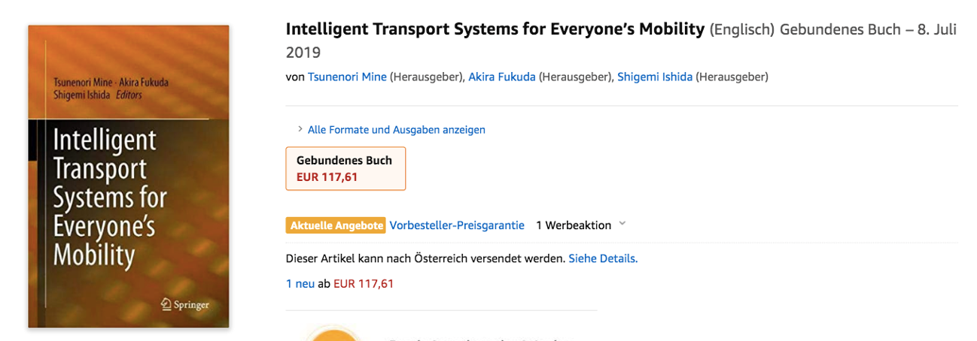

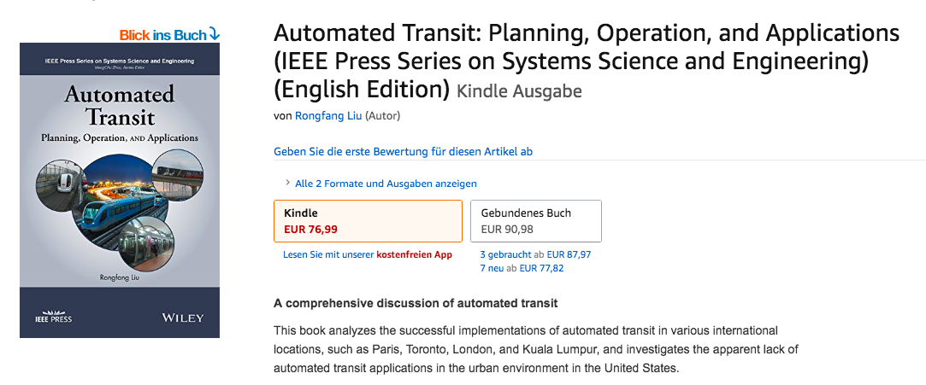



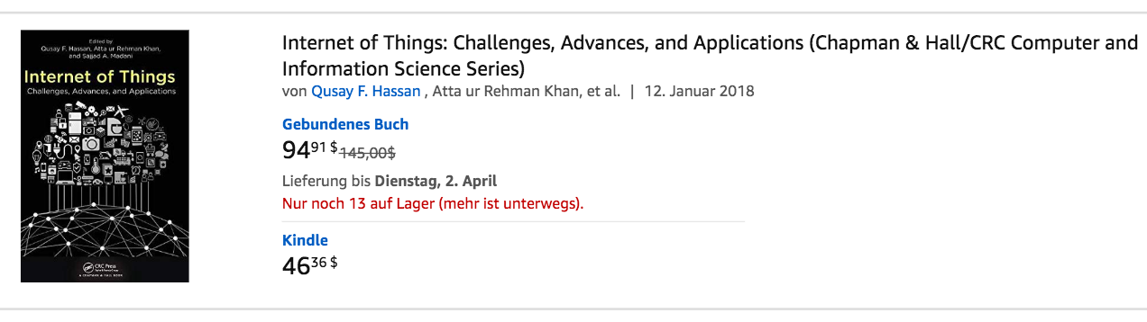




https://www.era.europa.eu/sites/default/files/activities/docs/cor_big_data_en.pdf
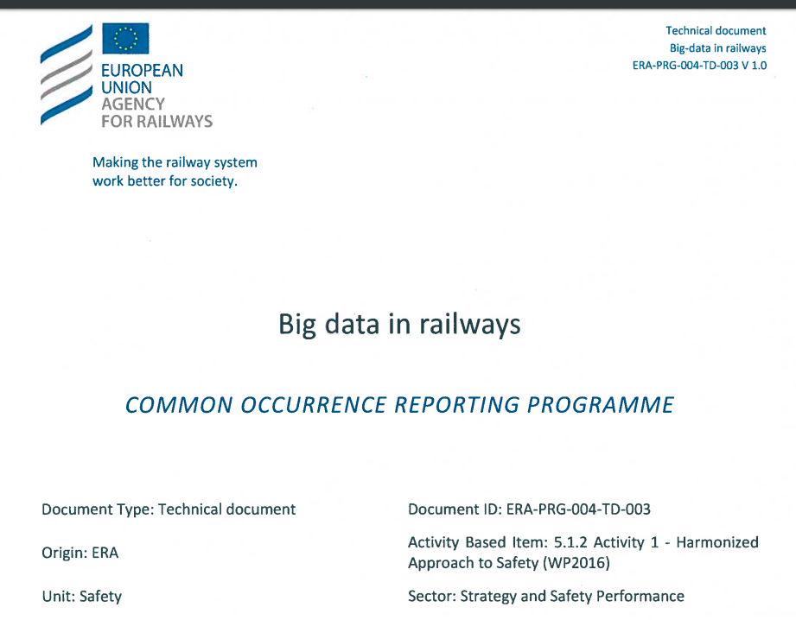

https://cyberleninka.org/article/n/1172453.pdf
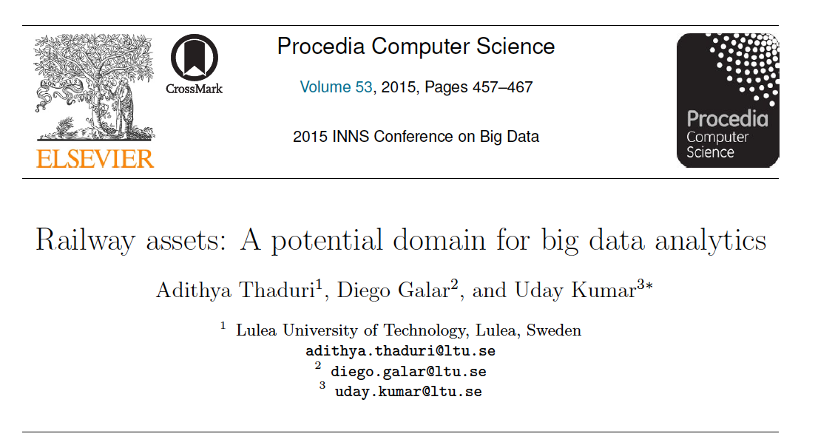

https://www.rssb.co.uk/Library/research-development-and-innovation/2018-01-T1138-Connected-Train-Customer-Communications.pdf

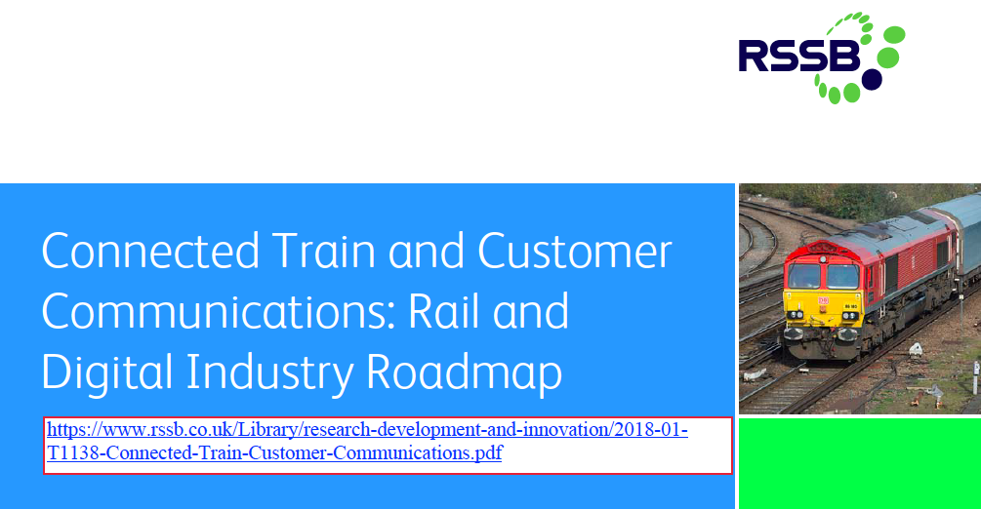

https://www2.vpe.hu/document/6304/Siemens_dr%20L%C3%A1szl%C3%B3%20Ludvig_Digitalization_The%20future%20of%20mobility.pdf

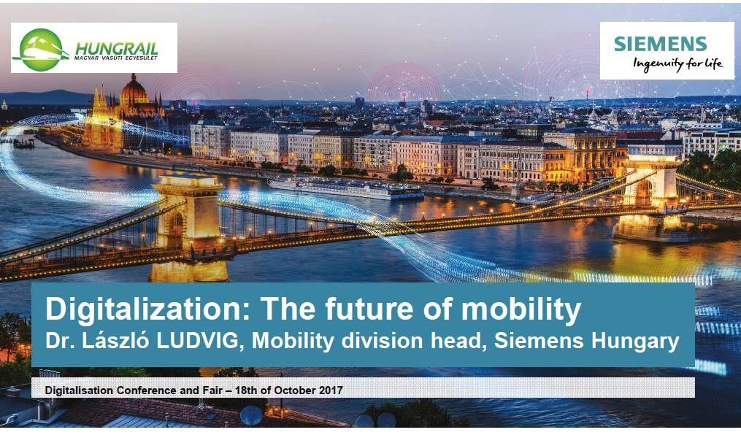

http://www.irse.org/knowledge/publicdocuments/3-2%20The%20GB%20Digital%20Railway_Martin%20Arter.pdf

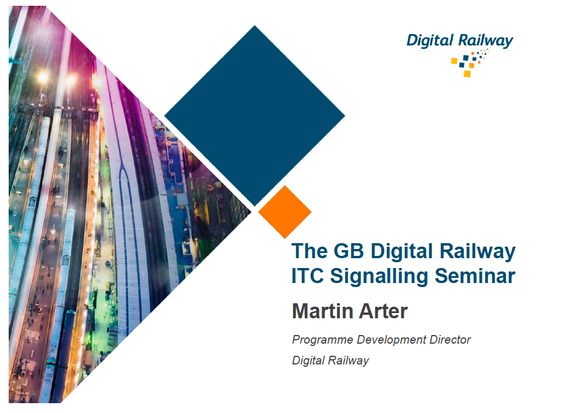

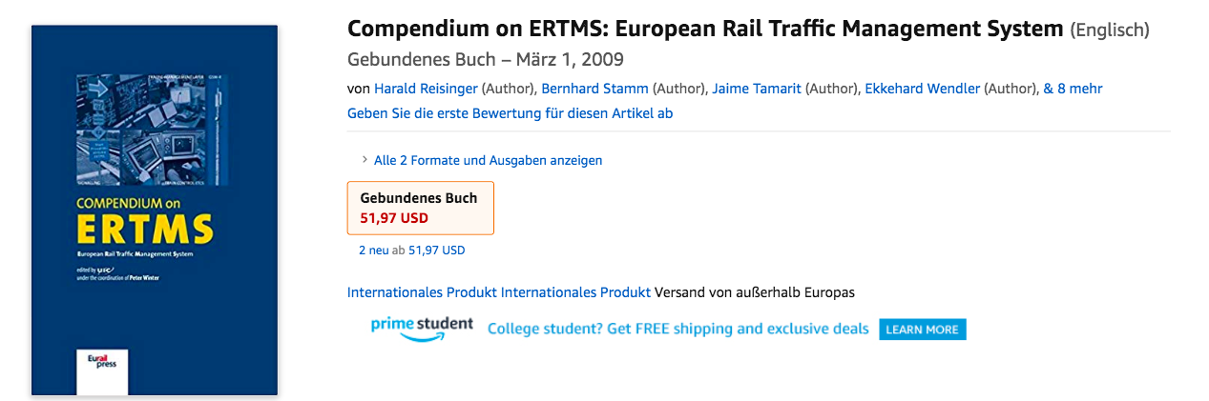

Source: https://www.amazon.com/dp/1483131378/ref=rdr_ext_tmb
https://www.fruct.org/publications/fruct22/files/Sne.pdf https://www.eurescom.eu/news-and-events/eurescommessage/eurescom-message-summer-2018/5g-for-railway-innovation.html https://commnet.ac.uk/wp-content/uploads/2017/07/Pres-6b.pdf https://cdn.networkrail.co.uk/wp-content/uploads/2019/02/Enabling-5G-for-the-rail.pdf
https://assets.new.siemens.com/siemens/assets/public.1522238318.64ecb0fe96953e47da65aa51ef13aa4003d34bee.simon-davidoff-digital-services-for-rail.pdf

