“In-Vehicle Information Systems”
Syllabus SCA.04/3

Prof K. Kyamakya, Prof J.C. Chedjou, AAU/Austria

October, 20th, 2018

Version 1

1. Title of the Course

In-Vehicle Information Systems
(Prof K. Kyamakya, Prof J.C. Chedjou, AAU/Austria)

2. ECTS Credits

5 credits (Lecture - 45 hours, Practice - 30 hours), 3rd semester

3. Course Objectives

In-vehicle information systems (IVIS) can provide drivers with information that is otherwise unavailable to them, such as road and traffic conditions, navigation information, weather conditions, hazard alerts, and business communication services.
One major purpose of the IS discipline is to ‘to understand and improve the ways people create value with information’, while studying the ‘understandings people require so they can create new value, and of the analysis, design, development, deployment, operation, and management of systems to inform these understandings’.
One understansd information systems as socio-technical systems, supporting users to execute tasks by providing task-relevant information.

4. The Contents of the Course

- Introduction and motivation
- Definition of vehicle information systems
- Scope and examples of vehicle information systems
- Vehicle Information System Architecture
  - Running controlling machine ((1) communication, (2) monitoring, (3) auxiliary driving, (4) environmental awareness, (5) help)
  - Information management machine ((6) communication, (7) monitoring, (8) Environmental awareness, (9) help, (10) Information querying, (10) auxiliary driving, (11) position navigation)
  - Security network communication machine ((12) communication, (13) help, (14) monitoring, (15) environmental awareness, (16) position navigation, (17) cooperative engagement, (18) remote operations)
  - Public network communication machine ((19) internet searching, (20) Internet data querying, (21) communication with other vehicles in the Internet)
- In-vehicle bus systems
  - CAN bus
  - Flexray
  - Others in-vehicle communication networks
  - Internet of vehicles
- In-vehicle information databases
- On-board vehicle cloud center information system
- Human factors and driver behaviour
  - Human factors
  - Driver behavior
  - Effect of human factors on driver behaviour
- Usability evaluation framework for in-vehicle information systems
  - Introduction
  - Preparing a usability evaluation
  - Selecting usability evaluation methods
  - Usability evaluation methods (analytic evaluation methods, empirical evaluation methods)
- Vehicle control systems and information systems
  - Introduction
  - Vehicle dynamics control systems
  - On-board environmental recognition sensors
  - Links between vehicle dynamics and information systems
- Vehicle services
  - Definition of vehicle services
  - From vehicles to vehicle services
  - Mobile services for vehicles
  - Conceptual Framework for remote vehicle diagnostics services
  - Vehicle ecosystem
    - What is a vehicle ecosystem
    - Traditional vehicle ecosystem
    - Electric vehicles ecosystem
    - Towards safe and secure autonomous and cooperative Vehicle Ecosystems
- Selected Topics for Students Research Seminars (2-3 students per group)
  - Data analytics and artificial intelligence for vehicle data processing
  - Wearables for vehicle information systems
  - Privacy, trust, security, safety, legal, moral and ethical aspects in vehicle data processing and usage
  - Standardization of vehicle interfaces and information
  - Business models and platform ecosystems in the context of Vehicle IS
  - Decision support systems (DSS) in the context of Vehicle IS
- Practical simulation experiments using the simulation tool VSimRTI

VSimRTI - Smart Mobility Simulation
- Field visit
- Visit one infrastructure/facility, a project, a manufacturer or a relevant service provider in the region

5. Software

VSimRTI – Smart Mobility Simulation
Link:
https://www.dcaiti.tu-berlin.de/research/simulation/
https://www.dcaiti.tu-berlin.de/research/simulation/download/

OpenDS 5.0 – Open Source Driving Simulation
Link:
https://opends.dfki.de/

6. Training method

Theoretical part of the course:
- Slides (to be placed in Moodle)
- Selected videos fitting the respective chapters (sources: Youtube, online open courses, etc.)
- Small weekly assignments. Deliverables-1: solutions to be uploaded in Moodle

Practical part of the course:
- Various simple simulations experiments using the named software tools
  - Deliverables-2: Demos to be presented in front of all the class
- 2 students mini-seminars in groups of 2 students
  - Deliverables-3 for each mini-seminar: 20 minutes presentations for each group
- A complex research project / study on a selected theme (teacher suggests some topics) of relevance to the course
  - The research project may involve also complex simulations
  - Deliverables-4: (1) a 20-30 minutes presentation; (2) A 6 pages paper/report summarizing the project/research outcome. Format: IEEE paper style. Paper editor: Latex.
- If possible, one industrial visit in a company working in one of the relevant fields

7. Evaluation method

Students are evaluated by progressive control/assessment through the 4 Deliverables listed above and a final written exam control.

The final grade has 2 major components:
- Deliverables-1: the weekly assignments accompanying the theoretical course: 10%
- 3 Deliverables: -2, -3, and -4: 50%
- Final written exam: 40%

8. Bibliography / Recommended textbooks

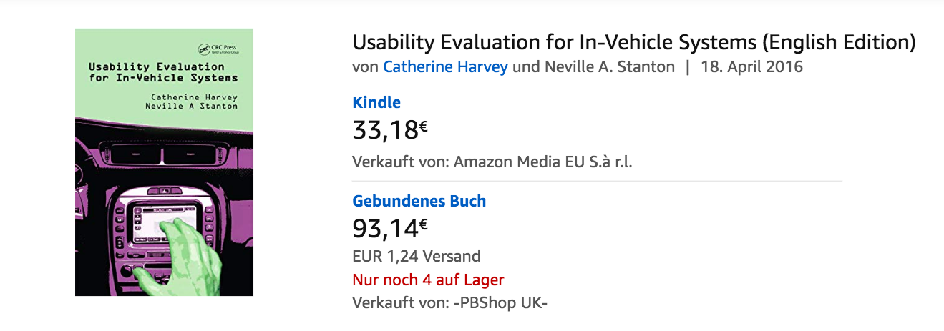
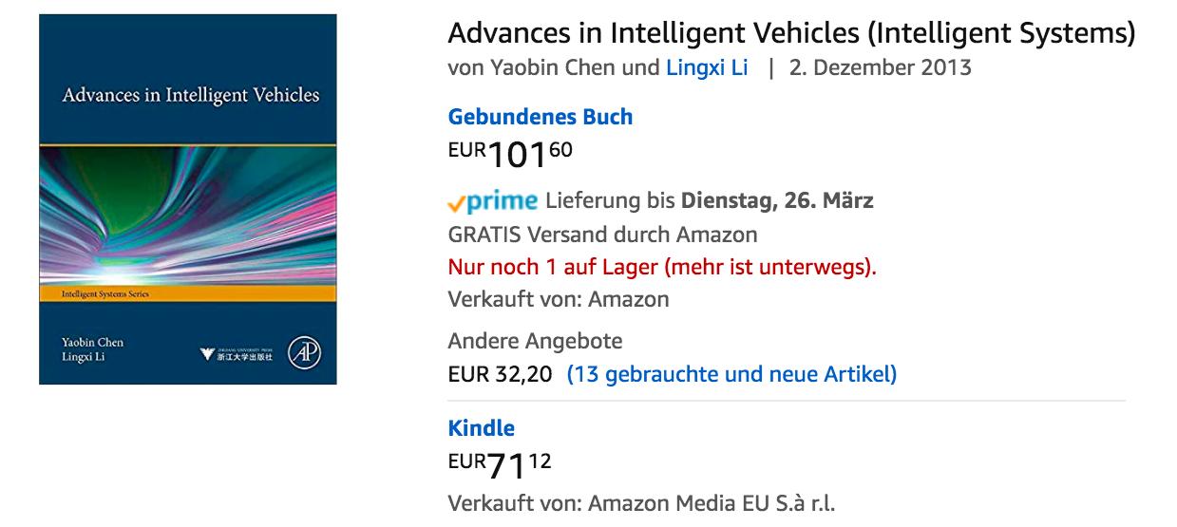
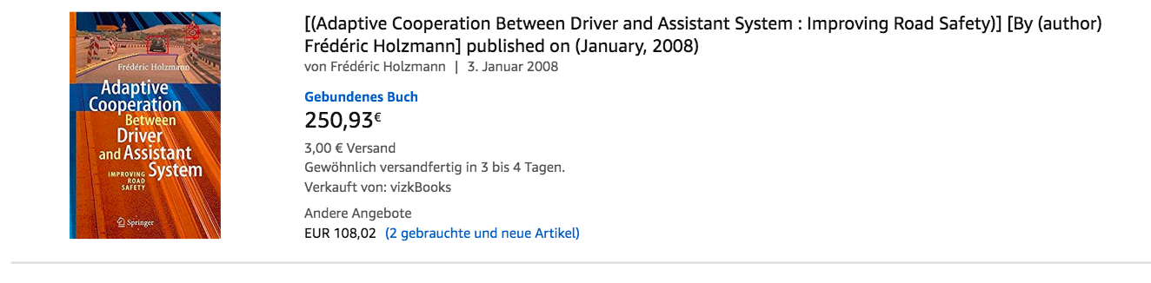

Source: Chapter 5 and 6 of book: https://www.amazon.de/dp/0123971993/ref=rdr_ext_tmb
Source: Chapter 4 of book: https://www.amazon.de/dp/B00CC6EBO6/ref=rdr_kindle_ext_tmb

